A visual guide for completing the Fishing License Issuing Agent Agreement

Each agent must complete information on pages 1, 7 and 8 of the agreement.

Page 1:
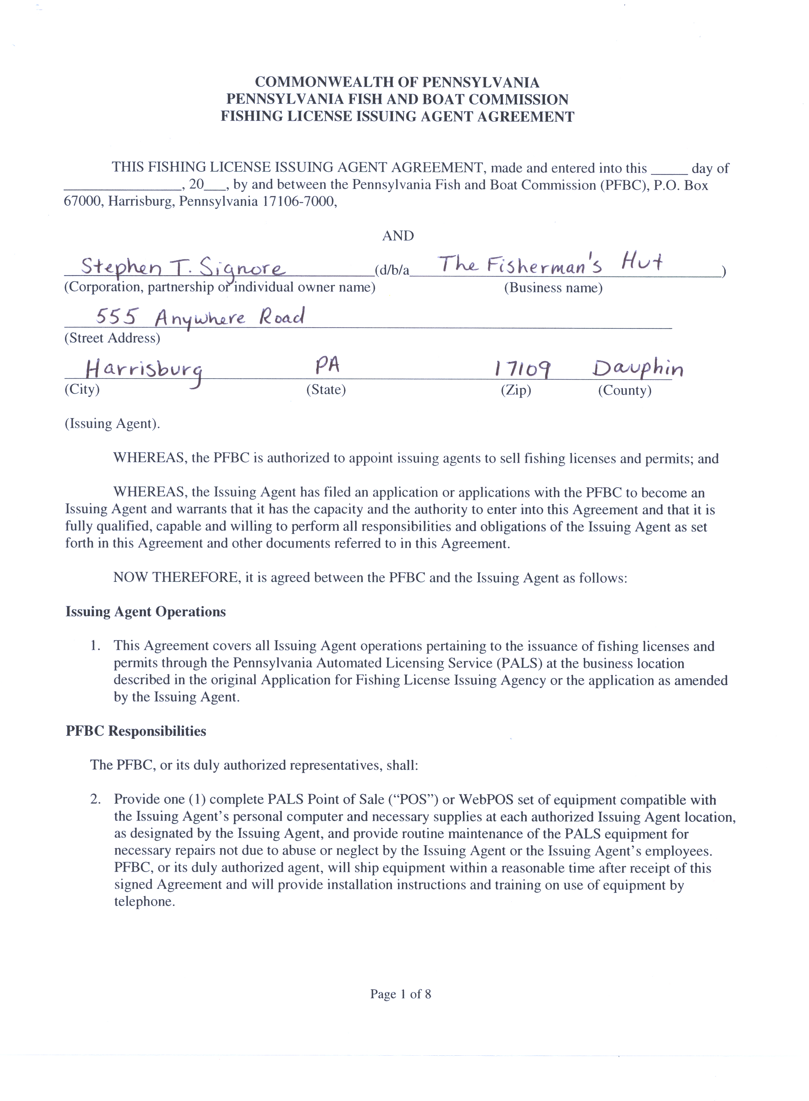
Do NOT Complete. PFBC Use Only.
Agent must enter name, name of business,
address and county.
Page 7:
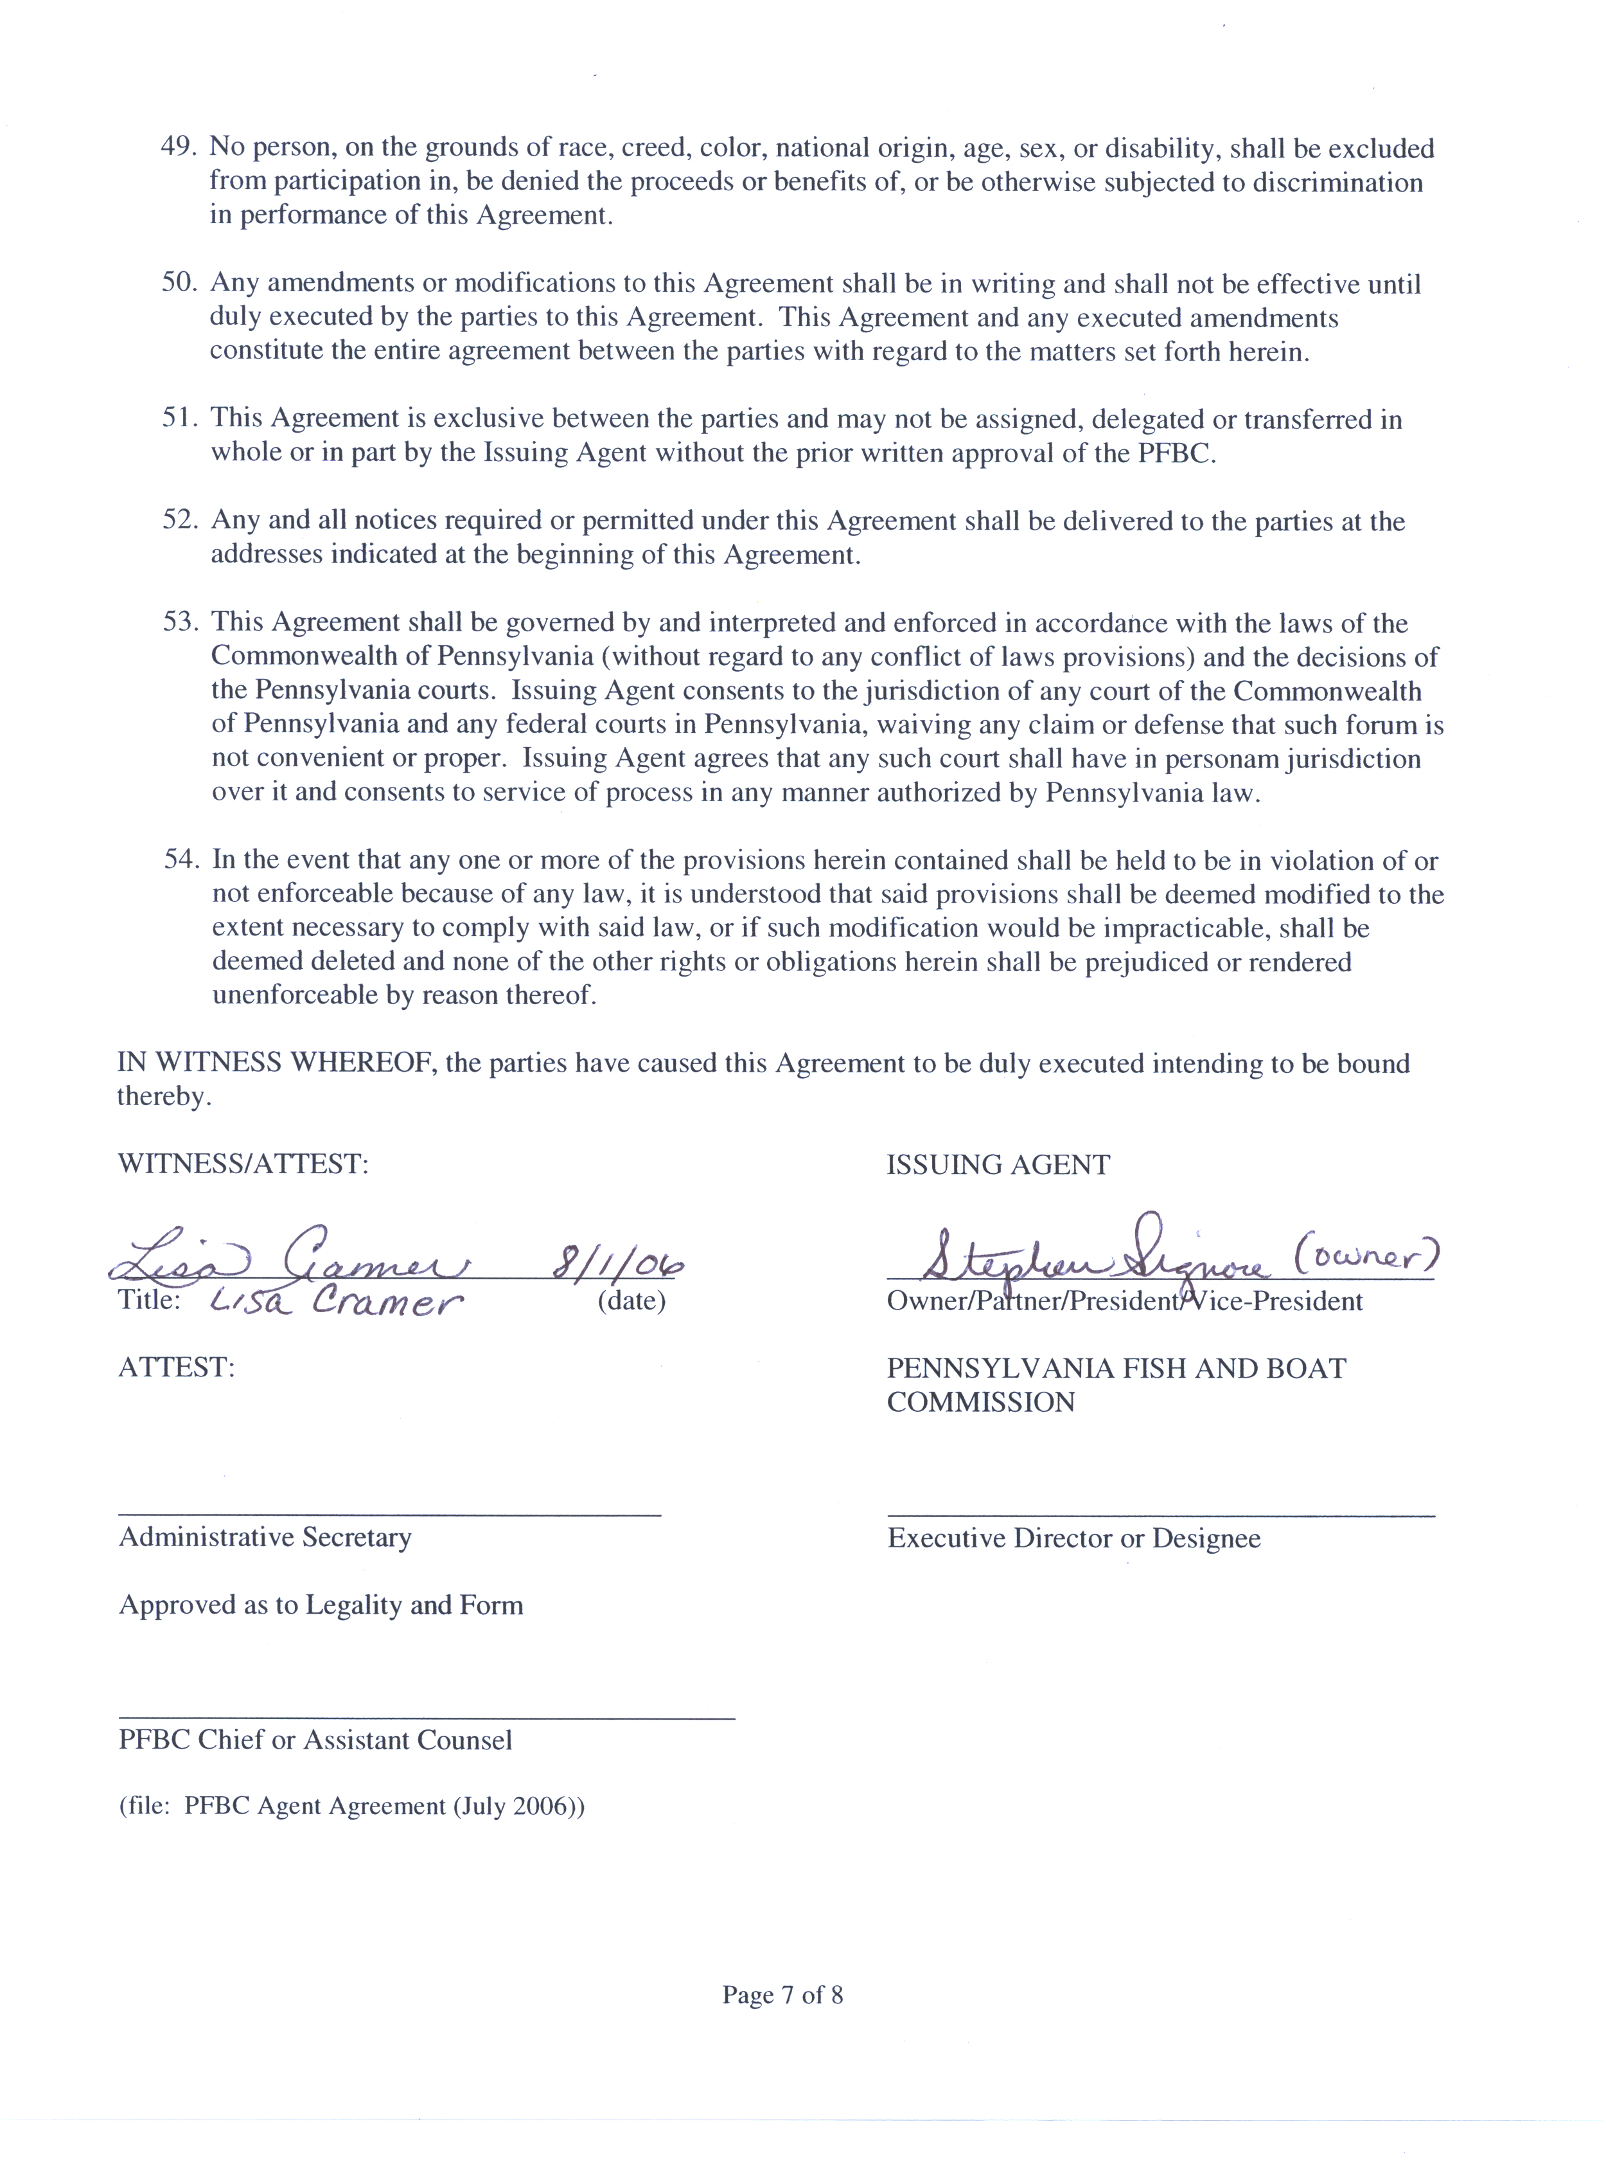
Witness or Authorized person must sign here. Write title of witness below signature. If no title, print witness name.
Agent or authorized person must sign, date and circle here.
Page 8:
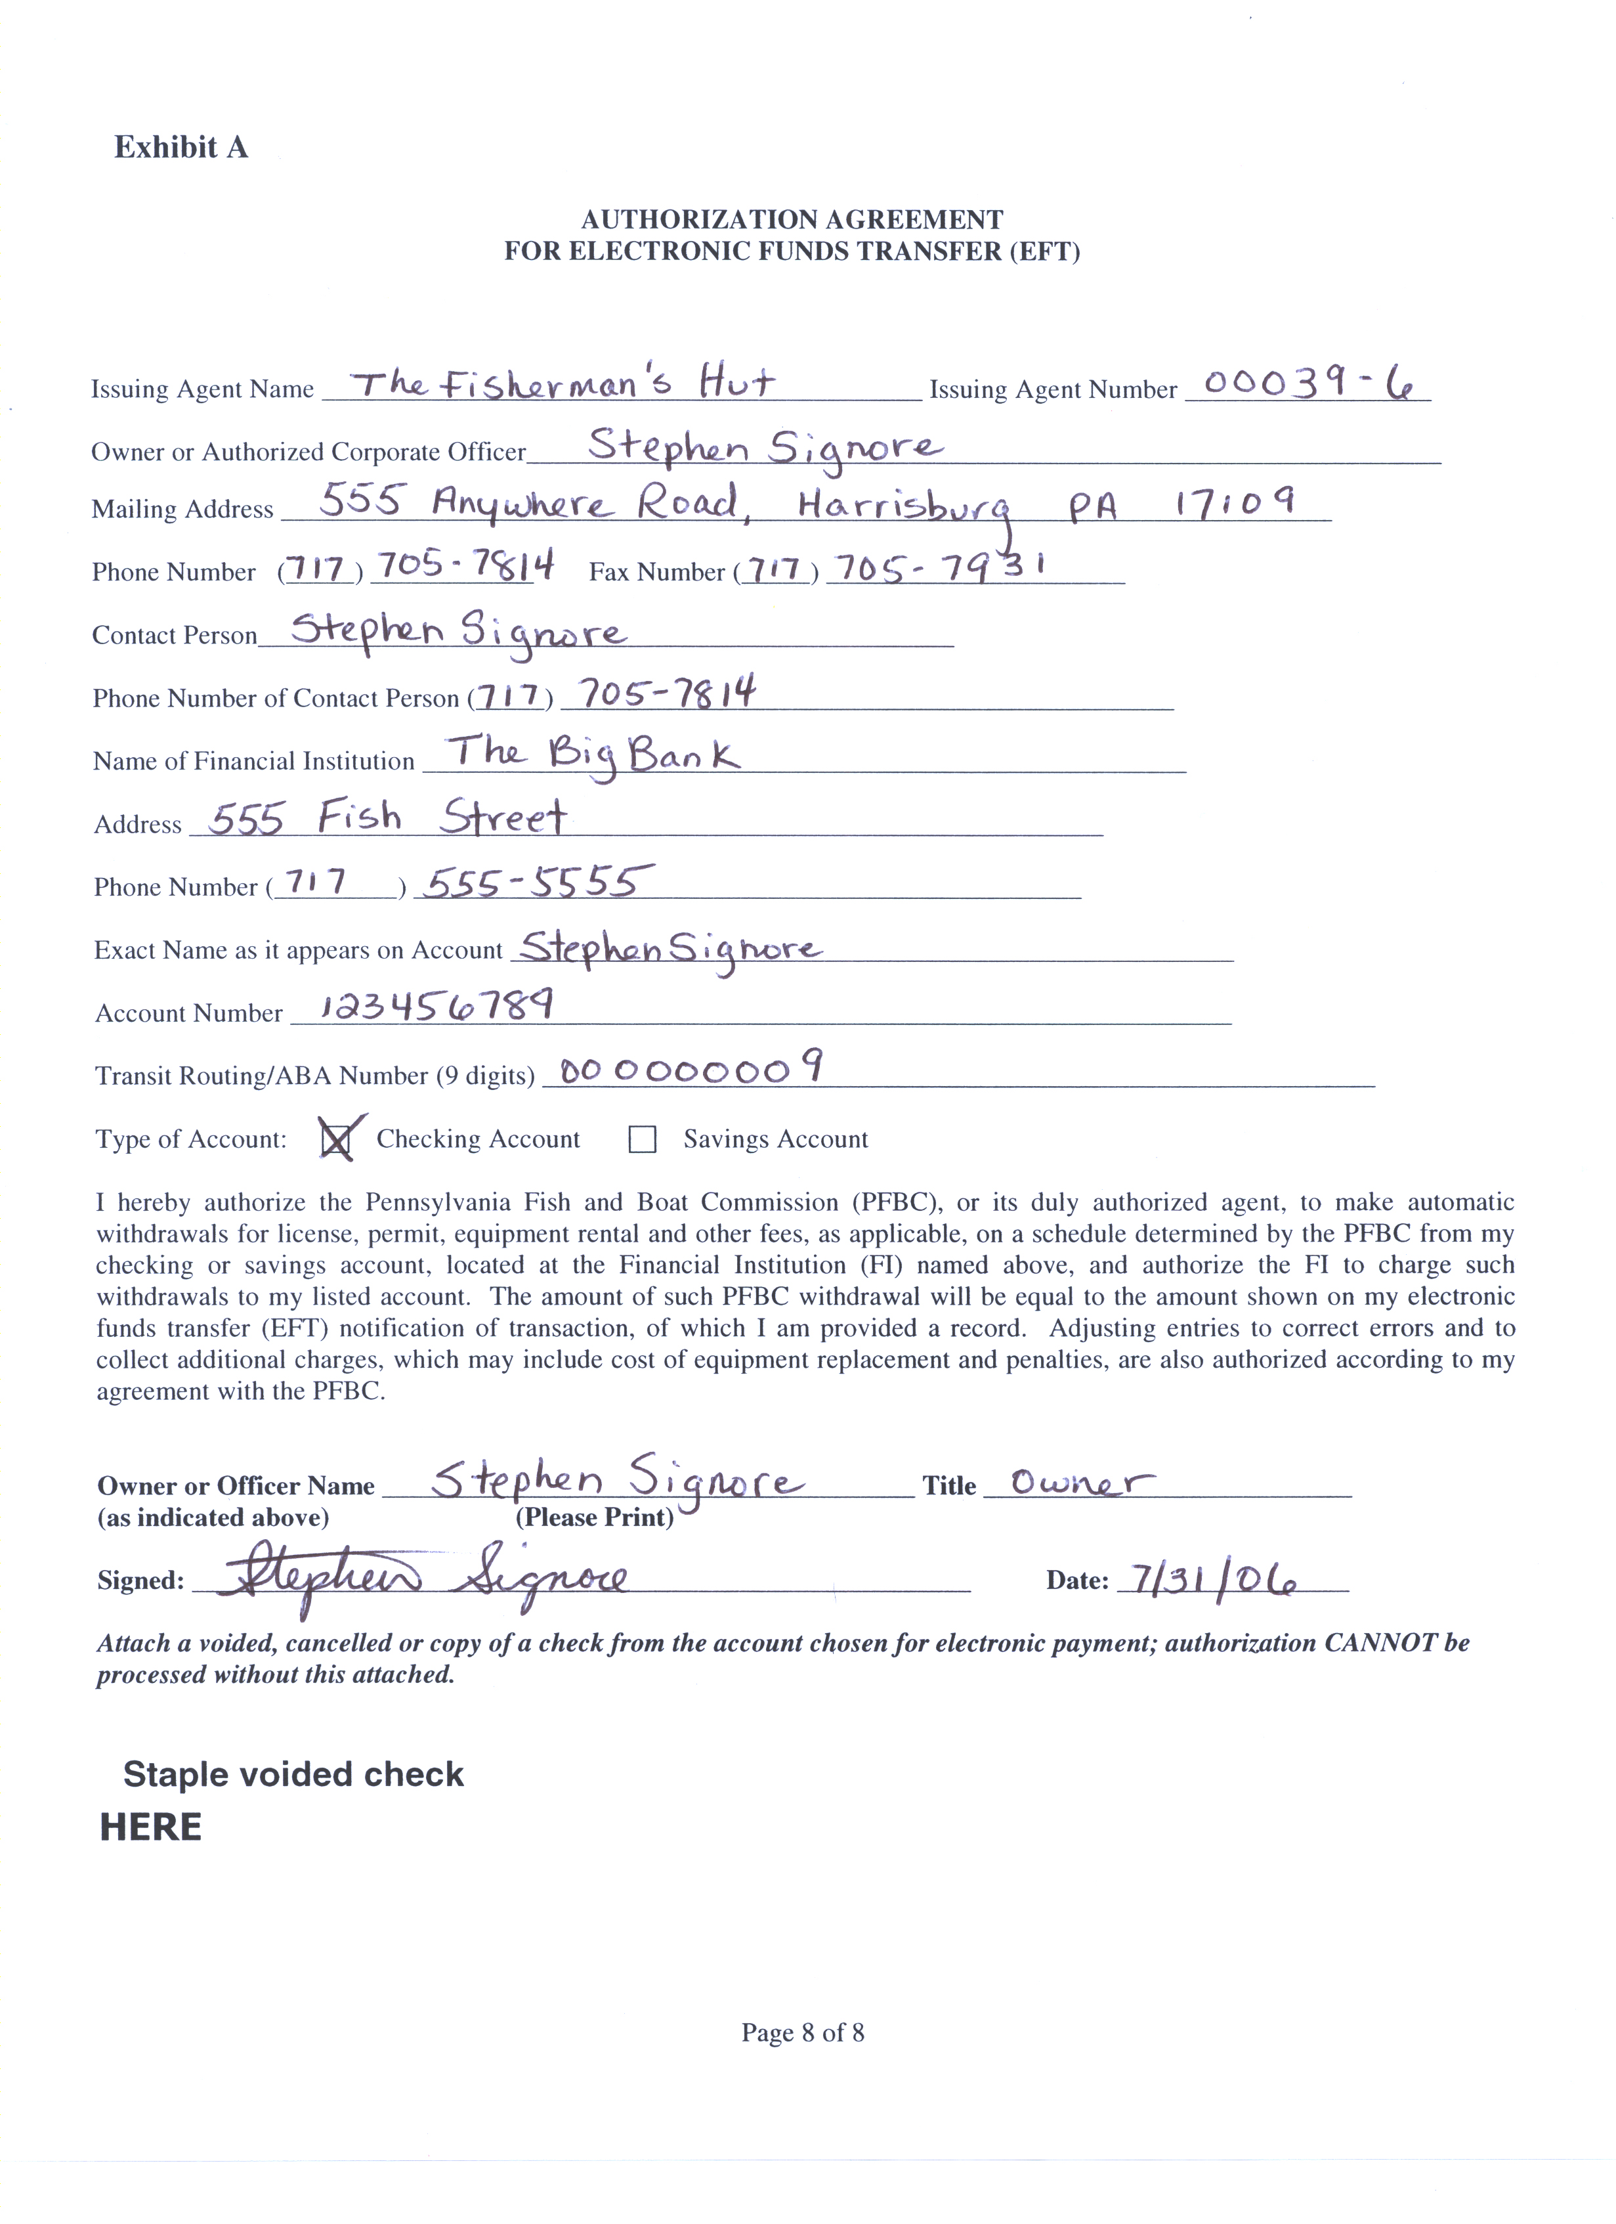
This section must be completely filled out by Agent.
Agent or Authorized person must sign and date.
Agent must attach a voided check here.
Please See Reverse For Signature Information

CONTRACT SIGNATURES

- When the Contractor is an Individual/Sole Proprietorship.

  - Signature by Owner. If the contract is signed by the individual owner, the execution is proper with the signature of a witness. If the company’s name is different than the individual’s name, the signature page should indicate that the individual who signed the signature page is the owner.

  - Signature by Someone Other than the Owner. If the contract is signed by someone other than the owner, a copy of the power of attorney from the owner authorizing the individual to sign contracts on behalf of the individual must be attached to the contract.

- When the Contractor is a Partnership.

  - Signature by Partner. If the contract is signed by a partner, the execution is proper without any additional signatures or documents. If the partnership is a limited partnership, only a general partner is authorized to sign on the partnership’s behalf. If the contract is signed by a partner, the title “partner” should appear below the signature of the partner. If it is signed by a general partner for a limited partnership, the title “general partner” should appear below the signature of the general partner.

  - Signature by Someone Other than a Partner. If the contract is not signed by a partner, then a copy of the power of attorney from on of the general partners authorizing the person to sign the contract must be attached to the contract.

- When the Contractor is a Corporation.

  - If the contract is signed by the president or vice president AND a secretary, assistant secretary, treasurer or assistant treasurer, the execution is proper and no additional signatures are required.

  - If someone other than the corporate officer signs, a corporate resolution or other documentation must be attached evidencing that person‘s authority to sign on behalf of the corporation.

- When the Contractor is Another Governmental Agency or Instrumentality. The contract should be signed by the person or persons authorized by statute to execute contracts on behalf of the governmental agency or instrumentality or specified by their resolution.

